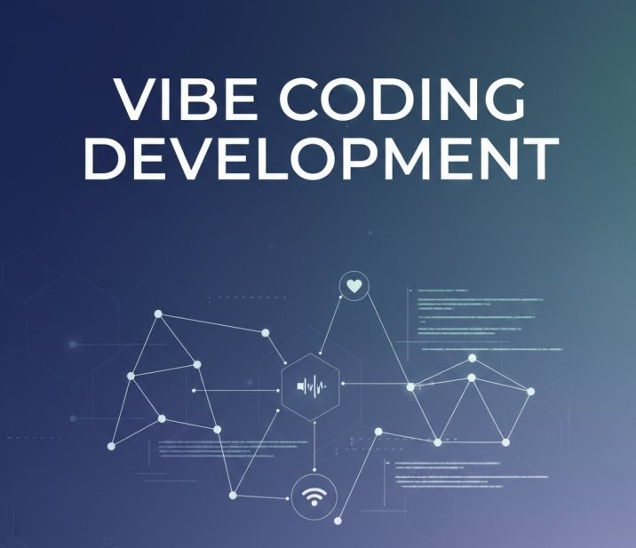
Video Relevance Scorer

Developed By: VE. Subassri

Contents
1. Tech Flow 3
2. Example Input / Output 3
3. Model Architecture 5
4.Screenshots 6

1. Tech Flow
- User Interaction
  - The Streamlit UI prompts for a YouTube URL (or a local .txt transcript), a video title, and an optional description.
  - UI widgets let the user set the chunk size (25 / 50 / 100 words) and an off-topic threshold.
- Data Ingestion
  - If a URL is supplied, youtube_transcript_api fetches the auto-generated transcript.
  - If a file is uploaded, its raw text is used directly.
- Embedding & Scoring
  - The title + description is encoded with a Sentence-Transformer (all-MiniLM-L6-v2, CPU-only).
  - The full transcript is split into overlapping word-chunks. Each chunk is encoded with the same model.
  - Cosine similarity between the query embedding and each chunk embedding yields a relevance score (0-100 %).
  - A simple regex scan flags chunks that contain promotional language.
- Explanation Generation
  - A short natural-language explanation is produced by Google Gemini 1.5-Flash using a prompt that includes the title, overall score, and any promotional flag.
- Result Presentation
  - Overall relevance metric and explanation are shown immediately.
  - Buttons reveal the raw transcript (collapsed by default) and a colour-coded bar chart (relevant = green, irrelevant = orange, promotional = red).
  - Off-topic chunks are highlighted based on the user-defined threshold.

2. Example Input / Output
Input (UI fields)
Field | Value
YouTube URL | https://www.youtube.com/watch?v=exampleID
Transcript file | uploaded – example.txt (contains ~2 min of spoken content)
Video Title | AI in Education
Description | A look at how AI tools are transforming classroom learning.
Chunk size | 50 words
Off-topic threshold | 30 %
Processing steps (behind the scenes)
- Title + description embedding → [1 × 384] vector.
- Transcript split into 4 chunks of 50 words each.
- Chunk embeddings → [4 × 384] matrix.
- Cosine similarities → [0.92, 0.78, 0.34, 0.87].
- Scores (rounded) → [92, 78, 34, 87].
- Promotional flag → True for chunk 3 (contains “subscribe”).
Output displayed in the app
- Relevance Score: 78 %
- Explanation: Content moderately matches the title “AI in Education” – 78% relevant. The transcript contains promotional language.
- Heat-map (coloured bars):
  - Segment 0 – relevant (92 %) – green
  - Segment 1 – relevant (78 %) – green
  - Segment 2 – promotional (34 %) – red (off-topic)
  - Segment 3 – relevant (87 %) – green
- Off-topic warning: 1 segment(s) look off-topic (segments 2)
- Transcript (collapsed): shows the raw text when the “Show transcript” button is pressed.

3. Model Architecture

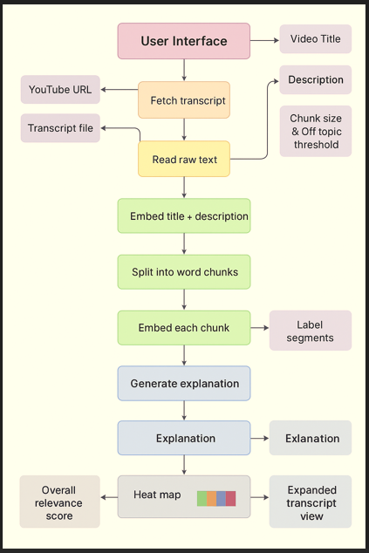

4.Screenshots

Detailed step by step demo video (check video)
streamlit-video_relevance_scorer-demo.webm

  - Fill the required details
a. Transcript
b. video title
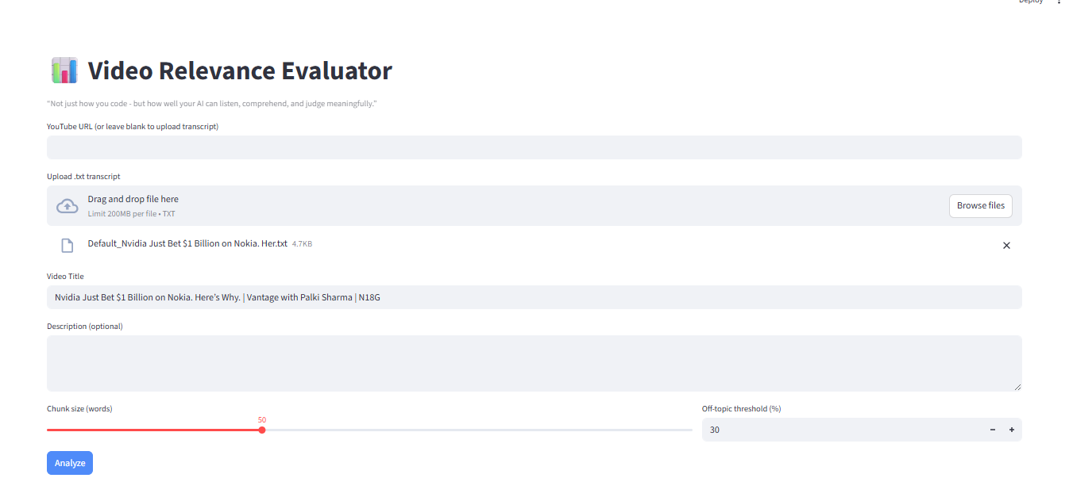
  - Post Generate button click below results display Relevant score, Relevance Heatmap, Transcripts details so on
